Naveen Kumar. T
Super set:6737302

- 1-Spring Data JPA - Quick Example
application.properties:

# Database configuration
spring.datasource.url=jdbc:mysql://localhost:3306/ormlearn
spring.datasource.username=root
spring.datasource.password=root
spring.datasource.driver-class-name=com.mysql.cj.jdbc.Driver

# Hibernate configuration
spring.jpa.hibernate.ddl-auto=validate
spring.jpa.show-sql=true

# Logging
logging.level.org.hibernate.SQL=DEBUG

Country.java:
package com.cognizant.ormlearn.model;

import jakarta.persistence.Entity;
import jakarta.persistence.Id;
import jakarta.persistence.Table;

@Entity
@Table(name="country")
public class Country {

@Id
private String code;

private String name;

public Country() {
}

public String getCode() {
return code;
}

public void setCode(String code) {
this.code = code;
}

public String getName() {
return name;
}

public void setName(String name) {
this.name = name;
}

@Override
public String toString() {
return "Country [code=" + code + ", name=" + name + "]";
}
}

CountryRepository.java:
package com.cognizant.ormlearn.repository;

import org.springframework.data.jpa.repository.JpaRepository;
import org.springframework.stereotype.Repository;

import com.cognizant.ormlearn.model.Country;

@Repository
public interface CountryRepository
extends JpaRepository<Country, String> {

}

CountryService.java:
package com.cognizant.ormlearn.service;

import java.util.List;

import org.springframework.beans.factory.annotation.Autowired;
import org.springframework.stereotype.Service;

import com.cognizant.ormlearn.model.Country;
import com.cognizant.ormlearn.repository.CountryRepository;

@Service
public class CountryService {

@Autowired
private CountryRepository countryRepository;

public List<Country> getAllCountries() {
return countryRepository.findAll();
}
}

OrmLearnApplication.java:
package com.cognizant.ormlearn;

import java.util.List;

import org.slf4j.Logger;
import org.slf4j.LoggerFactory;
import org.springframework.boot.SpringApplication;
import org.springframework.boot.autoconfigure.SpringBootApplication;
import org.springframework.context.ApplicationContext;

import com.cognizant.ormlearn.model.Country;
import com.cognizant.ormlearn.service.CountryService;

@SpringBootApplication
public class OrmLearnApplication {

private static final Logger LOGGER =
LoggerFactory.getLogger(OrmLearnApplication.class);

private static CountryService countryService;

public static void main(String[] args) {

ApplicationContext context =
SpringApplication.run(
OrmLearnApplication.class,
args);

countryService =
context.getBean(CountryService.class);

testGetAllCountries();

LOGGER.info("Inside main");
}

private static void testGetAllCountries() {

LOGGER.info("Start");

List<Country> countries =
countryService.getAllCountries();

LOGGER.info("Countries: {}", countries);

LOGGER.info("End");
}
}

Output:
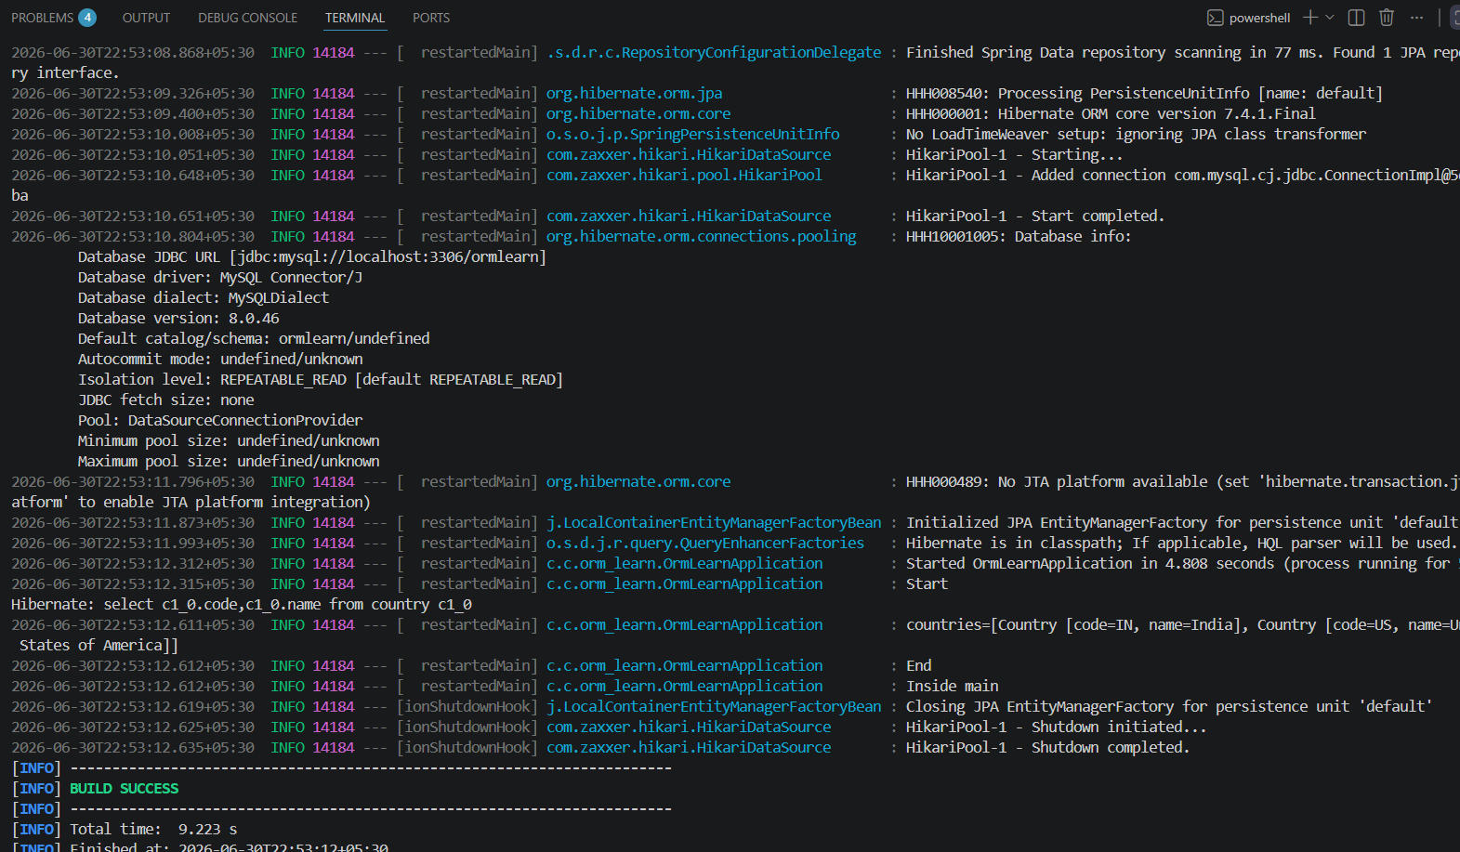

1)4-Difference between JPA, Hibernate and Spring Data JPA
Country.java:
package com.cognizant.orm_learn.model;

import jakarta.persistence.Entity;
import jakarta.persistence.Id;
import jakarta.persistence.Table;

@Entity
@Table(name = "country")
public class Country {

@Id
private String code;

private String name;

public Country() {
}

public Country(String code, String name) {
this.code = code;
this.name = name;
}

public String getCode() {
return code;
}

public void setCode(String code) {
this.code = code;
}

public String getName() {
return name;
}

public void setName(String name) {
this.name = name;
}
}

CountryRepository.java:
package com.cognizant.orm_learn.repository;

import org.springframework.data.jpa.repository.JpaRepository;
import com.cognizant.orm_learn.model.Country;

public interface CountryRepository
extends JpaRepository<Country, String> {

}

CountryService.java:
package com.cognizant.orm_learn.service;

import org.springframework.beans.factory.annotation.Autowired;
import org.springframework.stereotype.Service;

import com.cognizant.orm_learn.model.Country;
import com.cognizant.orm_learn.repository.CountryRepository;

@Service
public class CountryService {

@Autowired
private CountryRepository countryRepository;

public void addCountry() {

Country country = new Country("IN", "India");

countryRepository.save(country);

System.out.println("Country inserted successfully");
}
}

OrmApplication.java:
package com.cognizant.orm_learn;

import org.springframework.beans.factory.annotation.Autowired;
import org.springframework.boot.CommandLineRunner;
import org.springframework.boot.SpringApplication;
import org.springframework.boot.autoconfigure.SpringBootApplication;

import com.cognizant.orm_learn.service.CountryService;

@SpringBootApplication
public class OrmLearnApplication implements CommandLineRunner {

@Autowired
private CountryService countryService;

public static void main(String[] args) {
SpringApplication.run(
OrmLearnApplication.class,
args
);
}

@Override
public void run(String... args) {
countryService.addCountry();
}
}

Console output:
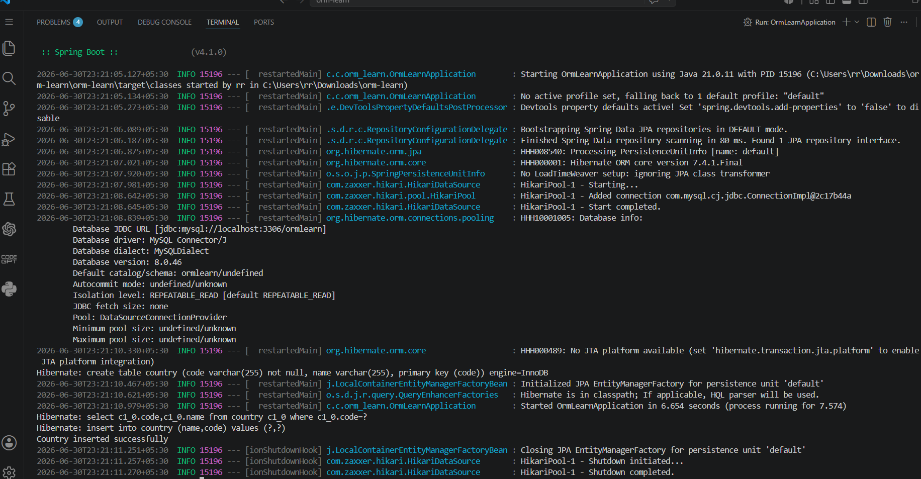
Database output:
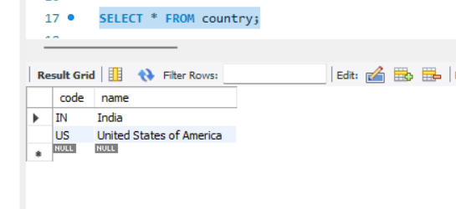

- 5-Implement services for managing Country

Country.java:
package com.cognizant.orm_learn.model;

import jakarta.persistence.Entity;
import jakarta.persistence.Id;
import jakarta.persistence.Table;

@Entity
@Table(name = "country")
public class Country {

@Id
private String code;

private String name;

public Country() {
}

public Country(String code, String name) {
this.code = code;
this.name = name;
}

public String getCode() {
return code;
}

public void setCode(String code) {
this.code = code;
}

public String getName() {
return name;
}

public void setName(String name) {
this.name = name;
}

@Override
public String toString() {
return "Country [code=" + code + ", name=" + name + "]";
}
}

CountryRepository.java:
package com.cognizant.orm_learn.repository;

import java.util.List;

import org.springframework.data.jpa.repository.JpaRepository;
import org.springframework.stereotype.Repository;

import com.cognizant.orm_learn.model.Country;

@Repository
public interface CountryRepository extends JpaRepository<Country, String> {

List<Country> findByNameContainingIgnoreCase(String name);

}

CountryService.java:
package com.cognizant.orm_learn.service;

import java.util.List;

import org.springframework.beans.factory.annotation.Autowired;
import org.springframework.stereotype.Service;

import com.cognizant.orm_learn.model.Country;
import com.cognizant.orm_learn.repository.CountryRepository;

@Service
public class CountryService {

@Autowired
private CountryRepository countryRepository;

public Country getCountry(String code) {
return countryRepository.findById(code).orElse(null);
}

public void addCountry(Country country) {
countryRepository.save(country);
System.out.println("Country added successfully");
}

public void updateCountry(Country country) {
countryRepository.save(country);
System.out.println("Country updated successfully");
}

public void deleteCountry(String code) {
countryRepository.deleteById(code);
System.out.println("Country deleted successfully");
}

public List<Country> searchCountry(String name) {
return countryRepository.findByNameContainingIgnoreCase(name);
}
}

OrmApplication.java:
package com.cognizant.orm_learn;

import org.springframework.beans.factory.annotation.Autowired;
import org.springframework.boot.CommandLineRunner;
import org.springframework.boot.SpringApplication;
import org.springframework.boot.autoconfigure.SpringBootApplication;

import com.cognizant.orm_learn.model.Country;
import com.cognizant.orm_learn.service.CountryService;

@SpringBootApplication
public class OrmLearnApplication implements CommandLineRunner {

@Autowired
private CountryService countryService;

public static void main(String[] args) {
SpringApplication.run(OrmLearnApplication.class, args);
}

@Override
public void run(String... args) {

System.out.println(countryService.getCountry("IN"));

countryService.addCountry(
new Country("NP", "Nepal"));

countryService.updateCountry(
new Country("NP", "Federal Democratic Republic of Nepal"));

countryService.deleteCountry("NP");

countryService.searchCountry("Uni")
.forEach(System.out::println);
}
}

application.properties:
spring.datasource.url=jdbc:mysql://localhost:3306/ormlearn
spring.datasource.username=root
spring.datasource.password=Naveen@2006

spring.jpa.show-sql=true
spring.jpa.hibernate.ddl-auto=update

Output:
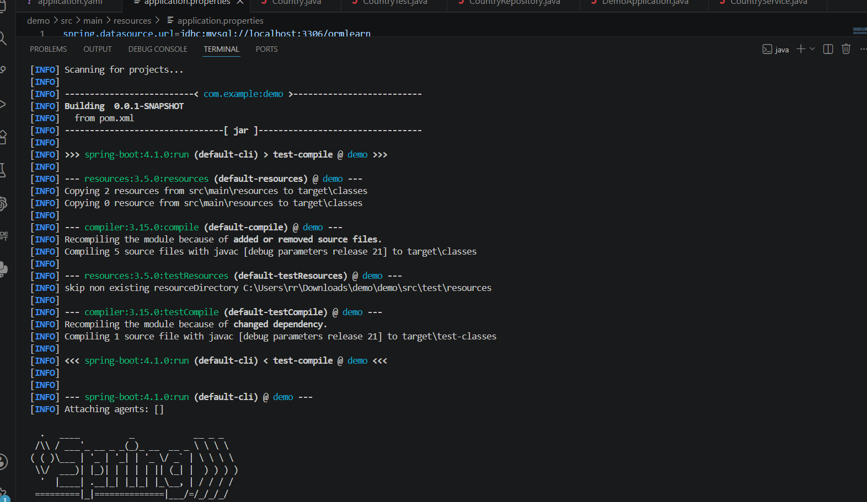
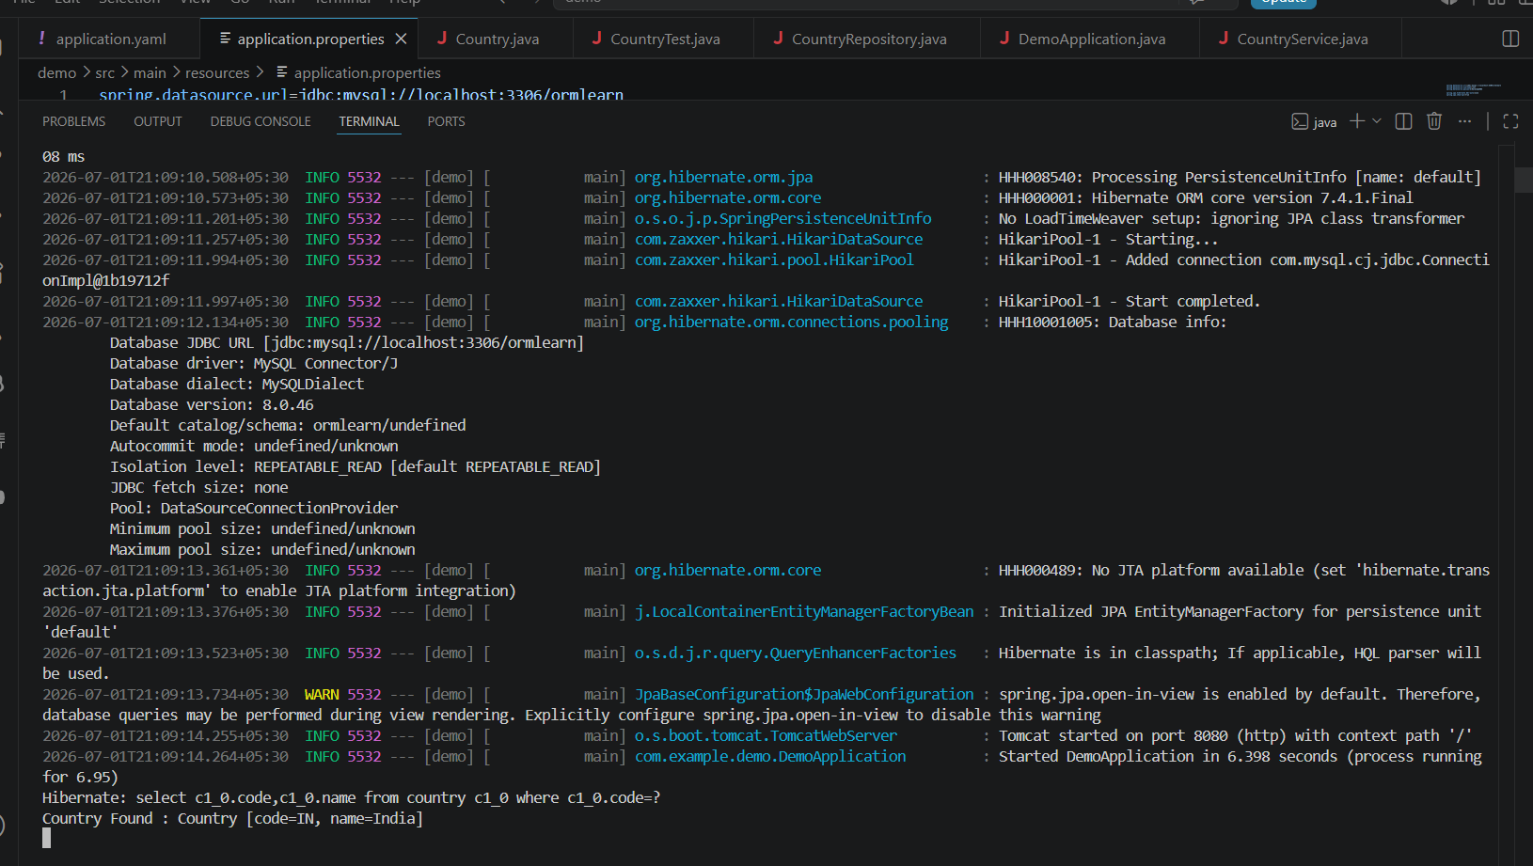

- 6-Find a country based on country code
CountryNotFoundException:
package com.example.demo.service.exception;

public class CountryNotFoundException extends Exception {

public CountryNotFoundException() {
super("Country not found");
}
}

CountryService.java:
package com.example.demo.service;

import java.util.Optional;

import org.springframework.beans.factory.annotation.Autowired;
import org.springframework.stereotype.Service;
import org.springframework.transaction.annotation.Transactional;

import com.example.demo.model.Country;
import com.example.demo.repository.CountryRepository;
import com.example.demo.service.exception.CountryNotFoundException;

@Service
public class CountryService {

@Autowired
private CountryRepository countryRepository;

@Transactional
public Country findCountryByCode(String countryCode)
throws CountryNotFoundException {

Optional<Country> result =
countryRepository.findById(countryCode);

if (!result.isPresent()) {
throw new CountryNotFoundException();
}

Country country = result.get();

return country;
}
}

CountryTest.java:
package com.example.demo;

import org.springframework.beans.factory.annotation.Autowired;
import org.springframework.boot.CommandLineRunner;
import org.springframework.stereotype.Component;

import com.example.demo.model.Country;
import com.example.demo.service.CountryService;
import com.example.demo.service.exception.CountryNotFoundException;

@Component
public class CountryTest implements CommandLineRunner {

@Autowired
private CountryService countryService;

@Override
public void run(String... args) throws Exception {

getCountryTest();
}

private void getCountryTest()
throws CountryNotFoundException {

System.out.println("Start");

Country country =
countryService.findCountryByCode("IN");

System.out.println("Country : " + country);

System.out.println("End");
}
}

CountryRepository.java:
package com.example.demo.repository;

import org.springframework.data.jpa.repository.JpaRepository;

import com.example.demo.model.Country;

public interface CountryRepository extends JpaRepository<Country, String> {

}

DemoApplication.java:
package com.example.demo;

import org.springframework.boot.SpringApplication;
import org.springframework.boot.autoconfigure.SpringBootApplication;

@SpringBootApplication
public class DemoApplication {

public static void main(String[] args) {
SpringApplication.run(DemoApplication.class, args);
}
}

Output:
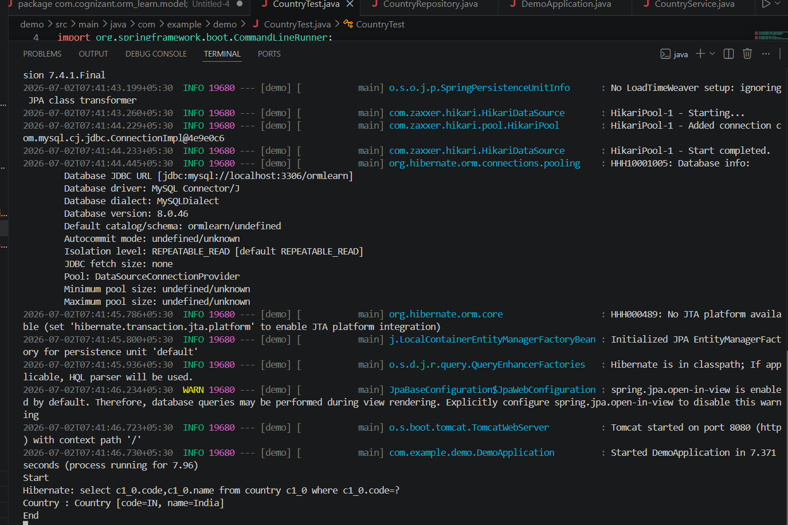

- 7-Add a new country

countryNotFoundException:

package com.example.demo.exception;

public class CountryNotFoundException extends Exception {

public CountryNotFoundException() {
super("Country not found");
}
}
Country.java:
package com.example.demo.model;

import jakarta.persistence.Entity;
import jakarta.persistence.Id;
import jakarta.persistence.Table;

@Entity
@Table(name = "country")
public class Country {

@Id
private String code;

private String name;

public Country() {
}

public Country(String code, String name) {
this.code = code;
this.name = name;
}

public String getCode() {
return code;
}

public void setCode(String code) {
this.code = code;
}

public String getName() {
return name;
}

public void setName(String name) {
this.name = name;
}

@Override
public String toString() {
return "Country [code=" + code + ", name=" + name + "]";
}
}

CountryRepository.java:
package com.example.demo.repository;

import org.springframework.data.jpa.repository.JpaRepository;

import com.example.demo.model.Country;

public interface CountryRepository extends JpaRepository<Country, String> {

}

CountryService.java:
package com.example.demo.service;

import java.util.Optional;

import org.springframework.beans.factory.annotation.Autowired;
import org.springframework.stereotype.Service;

import com.example.demo.exception.CountryNotFoundException;
import com.example.demo.model.Country;
import com.example.demo.repository.CountryRepository;

import jakarta.transaction.Transactional;

@Service
public class CountryService {

@Autowired
private CountryRepository countryRepository;

@Transactional
public Country findCountryByCode(String countryCode)
throws CountryNotFoundException {

Optional<Country> result =
countryRepository.findById(countryCode);

if (!result.isPresent()) {
throw new CountryNotFoundException();
}

return result.get();
}

@Transactional
public void addCountry(Country country) {
countryRepository.save(country);
}
}

Output:

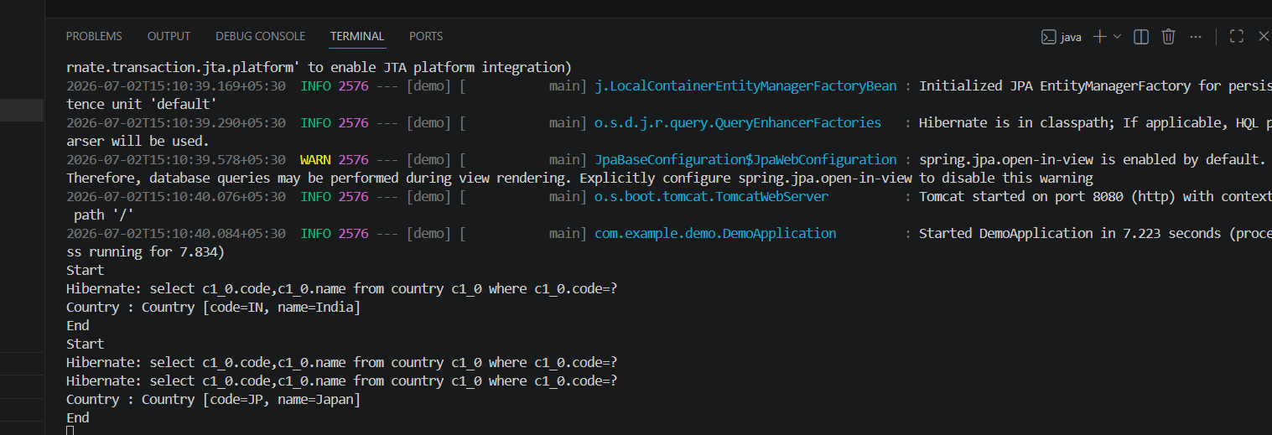
- 1-Demonstrate implementation of Query Methods feature of Spring Data JPA:

Employee.java:
package com.example.querymethods.model;

import jakarta.persistence.*;
import java.time.LocalDate;

@Entity
public class Employee {

@Id
@GeneratedValue(strategy = GenerationType.IDENTITY)
private Long id;

private String name;

private double salary;

private LocalDate joiningDate;

public Employee() {
}

public Employee(String name, double salary, LocalDate joiningDate) {
this.name = name;
this.salary = salary;
this.joiningDate = joiningDate;
}

public Long getId() {
return id;
}

public String getName() {
return name;
}

public double getSalary() {
return salary;
}

public LocalDate getJoiningDate() {
return joiningDate;
}

@Override
public String toString() {
return "Employee{" +
"id=" + id +
", name='" + name + '\'' +
", salary=" + salary +
", joiningDate=" + joiningDate +
'}';
}
}
EmployeeRepository.java:
package com.example.querymethods.repository;

import com.example.querymethods.model.Employee;
import org.springframework.data.jpa.repository.JpaRepository;

import java.time.LocalDate;
import java.util.List;

public interface EmployeeRepository
extends JpaRepository<Employee, Long> {

List<Employee> findByNameContaining(String text);

List<Employee> findByNameStartingWith(String text);

List<Employee> findBySalaryGreaterThan(double salary);

List<Employee> findBySalaryLessThan(double salary);

List<Employee> findTop3ByOrderBySalaryDesc();

List<Employee> findAllByOrderBySalaryAsc();

List<Employee> findByJoiningDateBetween(
LocalDate start,
LocalDate end);
}
DataRunner.java:
package com.example.querymethods.runner;

import com.example.querymethods.model.Employee;
import com.example.querymethods.repository.EmployeeRepository;
import org.springframework.boot.CommandLineRunner;
import org.springframework.stereotype.Component;

import java.time.LocalDate;

@Component
public class DataRunner implements CommandLineRunner {

private final EmployeeRepository repository;

public DataRunner(EmployeeRepository repository) {
this.repository = repository;
}

@Override
public void run(String... args) {

repository.save(new Employee(
"Naveen",
50000,
LocalDate.of(2024, 1, 10)));

repository.save(new Employee(
"Arun",
70000,
LocalDate.of(2023, 5, 20)));

repository.save(new Employee(
"Karthik",
60000,
LocalDate.of(2022, 3, 15)));

repository.save(new Employee(
"Nandha",
80000,
LocalDate.of(2021, 8, 5)));

System.out.println("\nNames containing 'av'");
repository.findByNameContaining("av")
.forEach(System.out::println);

System.out.println("\nNames starting with 'Na'");
repository.findByNameStartingWith("Na")
.forEach(System.out::println);

System.out.println("\nSalary greater than 60000");
repository.findBySalaryGreaterThan(60000)
.forEach(System.out::println);

System.out.println("\nSalary less than 70000");
repository.findBySalaryLessThan(70000)
.forEach(System.out::println);

System.out.println("\nTop 3 salaries");
repository.findTop3ByOrderBySalaryDesc()
.forEach(System.out::println);

System.out.println("\nSorted by salary");
repository.findAllByOrderBySalaryAsc()
.forEach(System.out::println);

System.out.println("\nJoining date between 2022 and 2024");
repository.findByJoiningDateBetween(
LocalDate.of(2022,1,1),
LocalDate.of(2024,12,31))
.forEach(System.out::println);
}
}
QuerymethodsApplication.java:
package com.example.querymethods;

import org.springframework.boot.SpringApplication;
import org.springframework.boot.autoconfigure.SpringBootApplication;

@SpringBootApplication
public class QuerymethodsApplication {

public static void main(String[] args) {
SpringApplication.run(QuerymethodsApplication.class, args);
}

}

spring.datasource.url=jdbc:mysql://localhost:3306/querydb
spring.datasource.username=root
spring.datasource.password=Naveen@2006

spring.jpa.hibernate.ddl-auto=create
spring.jpa.show-sql=true
Output:
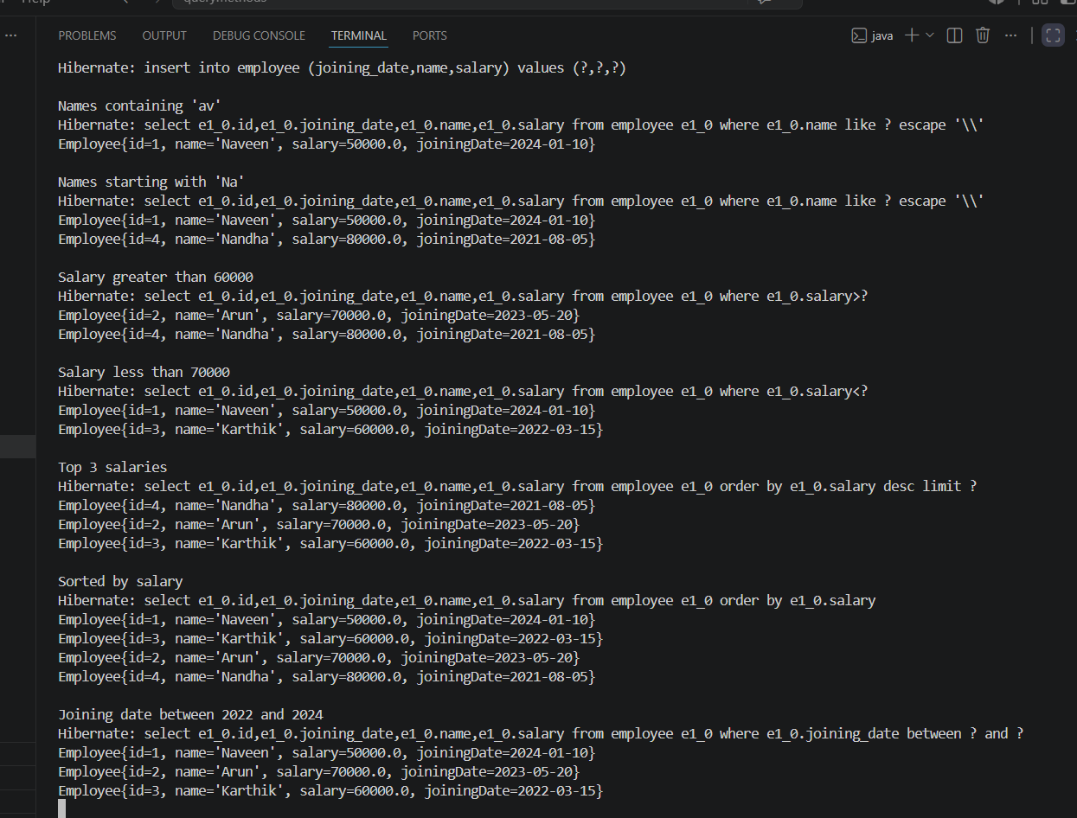

- 2-Demonstrate implementation of O/R Mapping

Course.java:
package com.example.ormrelationships.model;

import jakarta.persistence.*;
import java.util.List;

@Entity
public class Course {

@Id
@GeneratedValue(strategy = GenerationType.IDENTITY)
private Long id;

private String name;

@ManyToMany(mappedBy = "courses")
private List<Student> students;

public Course() {
}

public Course(String name) {
this.name = name;
}
}

Department.java:
package com.example.ormrelationships.model;

import jakarta.persistence.*;
import java.util.List;

@Entity
public class Department {

@Id
@GeneratedValue(strategy = GenerationType.IDENTITY)
private Long id;

private String name;

@OneToMany(
mappedBy = "department",
fetch = FetchType.LAZY)
private List<Employee> employees;

public Department() {
}

public Department(String name) {
this.name = name;
}

public Long getId() {
return id;
}

public String getName() {
return name;
}
}
Employee.java:
package com.example.ormrelationships.model;

import jakarta.persistence.*;

@Entity
public class Employee {

@Id
@GeneratedValue(strategy = GenerationType.IDENTITY)
private Long id;

private String name;

@ManyToOne(fetch = FetchType.EAGER)
@JoinColumn(name = "department_id")
private Department department;

public Employee() {
}

public Employee(String name, Department department) {
this.name = name;
this.department = department;
}

@Override
public String toString() {
return "Employee{" +
"name='" + name + '\'' +
", department=" + department.getName() +
'}';
}
}

Student.java:
package com.example.ormrelationships.model;

import jakarta.persistence.*;
import java.util.List;

@Entity
public class Student {

@Id
@GeneratedValue(strategy = GenerationType.IDENTITY)
private Long id;

private String name;

@ManyToMany
@JoinTable(
name = "student_course",
joinColumns =
@JoinColumn(name = "student_id"),
inverseJoinColumns =
@JoinColumn(name = "course_id")
)
private List<Course> courses;

public Student() {
}

public Student(String name, List<Course> courses) {
this.name = name;
this.courses = courses;
}
}
CourseRepository.java:
package com.example.ormrelationships.repository;

import com.example.ormrelationships.model.Course;
import org.springframework.data.jpa.repository.JpaRepository;

public interface CourseRepository
extends JpaRepository<Course, Long> {
}
DepartmentRepository.java:
package com.example.ormrelationships.repository;

import com.example.ormrelationships.model.Department;
import org.springframework.data.jpa.repository.JpaRepository;

public interface DepartmentRepository
extends JpaRepository<Department, Long> {
}
EmployeeRepository.java:
package com.example.ormrelationships.repository;

import com.example.ormrelationships.model.Employee;
import org.springframework.data.jpa.repository.JpaRepository;

public interface EmployeeRepository
extends JpaRepository<Employee, Long> {
}
StudentRepository.java:
package com.example.ormrelationships.repository;

import com.example.ormrelationships.model.Student;
import org.springframework.data.jpa.repository.JpaRepository;

public interface StudentRepository
extends JpaRepository<Student, Long> {
}
DataRunner.java:
package com.example.ormrelationships.runner;

import com.example.ormrelationships.model.*;
import com.example.ormrelationships.repository.*;
import org.springframework.boot.CommandLineRunner;
import org.springframework.stereotype.Component;

import java.util.Arrays;

@Component
public class DataRunner implements CommandLineRunner {

private final DepartmentRepository departmentRepository;
private final EmployeeRepository employeeRepository;
private final CourseRepository courseRepository;
private final StudentRepository studentRepository;

public DataRunner(
DepartmentRepository departmentRepository,
EmployeeRepository employeeRepository,
CourseRepository courseRepository,
StudentRepository studentRepository) {

this.departmentRepository = departmentRepository;
this.employeeRepository = employeeRepository;
this.courseRepository = courseRepository;
this.studentRepository = studentRepository;
}

@Override
public void run(String... args) {

Department it = departmentRepository.save(
new Department("IT"));

Department hr = departmentRepository.save(
new Department("HR"));

employeeRepository.save(
new Employee("Naveen", it));

employeeRepository.save(
new Employee("Arun", it));

employeeRepository.save(
new Employee("Karthik", hr));

Course java = courseRepository.save(
new Course("Java"));

Course spring = courseRepository.save(
new Course("Spring Boot"));

studentRepository.save(
new Student(
"Naveen",
Arrays.asList(java, spring)));

System.out.println("ORM Relationships Created Successfully");
}
}
OrmrelationshipsApplication.java:
package com.example.ormrelationships;

import org.springframework.boot.SpringApplication;
import org.springframework.boot.autoconfigure.SpringBootApplication;

@SpringBootApplication
public class OrmrelationshipsApplication {

public static void main(String[] args) {
SpringApplication.run(OrmrelationshipsApplication.class, args);
}

}

Output:
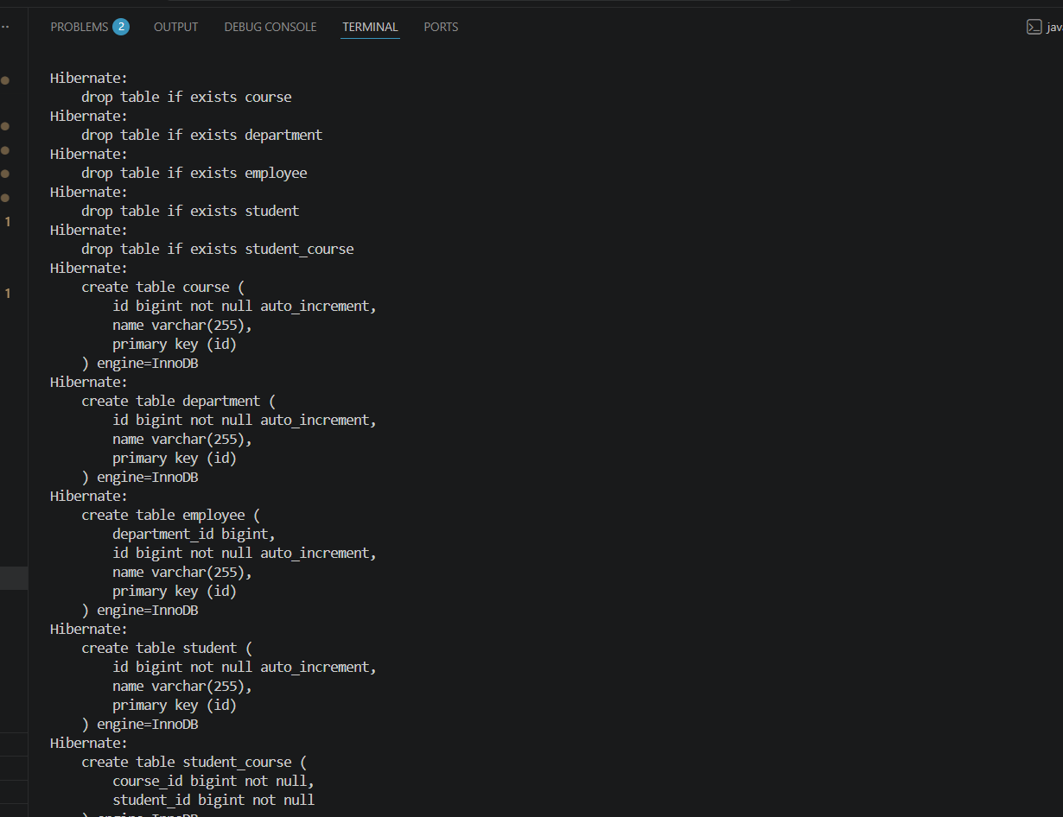
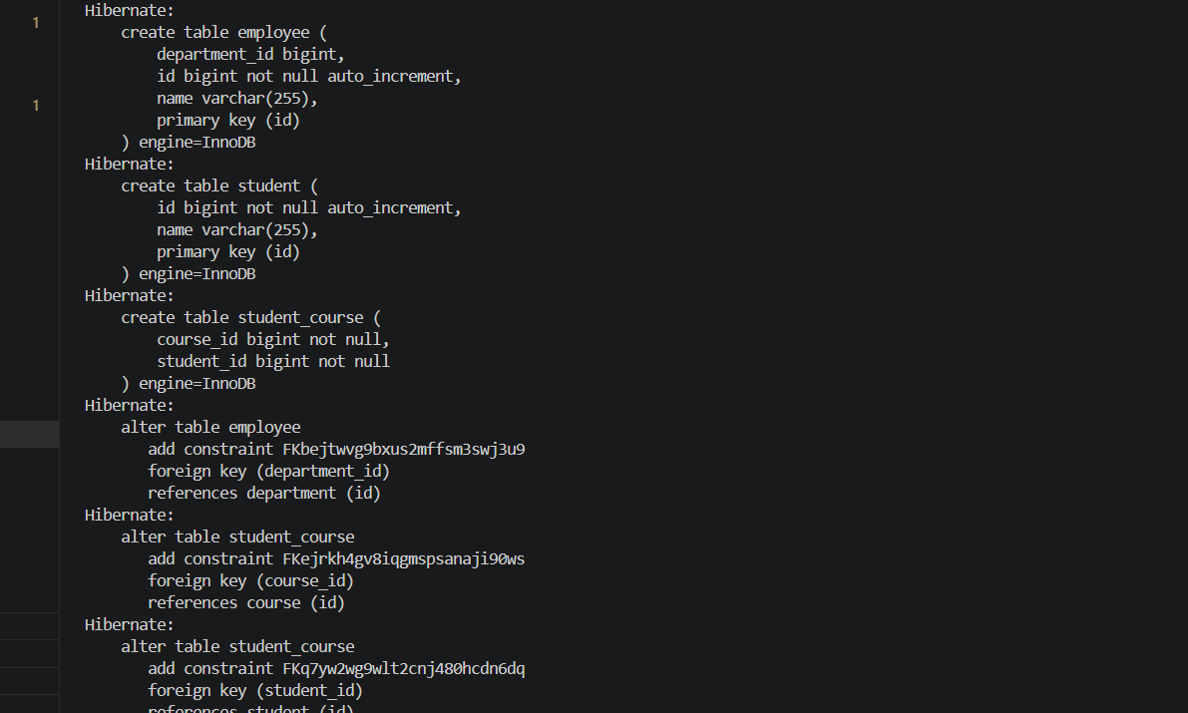

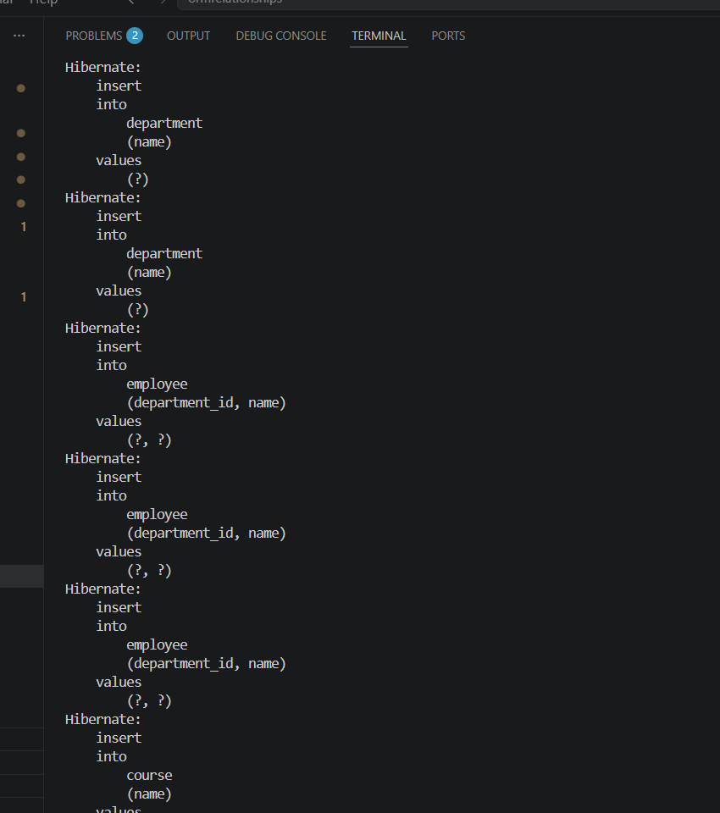
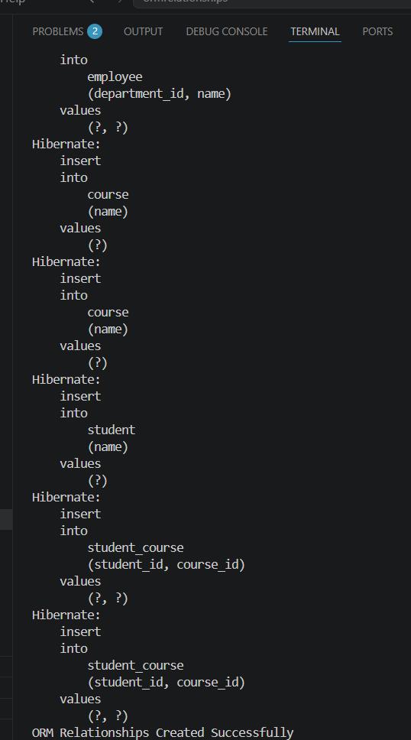
- Demonstrate writing Hibernate Query Language and Native Query

Employee.java:
package com.example.hqlnativequery.model;

import jakarta.persistence.*;

@Entity
public class Employee {

@Id
@GeneratedValue(strategy = GenerationType.IDENTITY)
private Long id;

private String name;

private double salary;

public Employee() {
}

public Employee(String name, double salary) {
this.name = name;
this.salary = salary;
}

@Override
public String toString() {
return "Employee{" +
"id=" + id +
", name='" + name + '\'' +
", salary=" + salary +
'}';
}
}
EmployeeRepository.java:
package com.example.hqlnativequery.repository;

import com.example.hqlnativequery.model.Employee;
import org.springframework.data.jpa.repository.JpaRepository;
import org.springframework.data.jpa.repository.Query;

import java.util.List;

public interface EmployeeRepository
extends JpaRepository<Employee, Long> {

// HQL Query
@Query("FROM Employee")
List<Employee> getAllEmployees();

// HQL with condition
@Query("FROM Employee e WHERE e.salary > ?1")
List<Employee> getEmployeesAboveSalary(double salary);

// Aggregate Function
@Query("SELECT AVG(e.salary) FROM Employee e")
Double getAverageSalary();

// Native Query
@Query(
value = "SELECT * FROM employee WHERE salary < ?1",
nativeQuery = true
)
List<Employee> getEmployeesBelowSalary(double salary);
}
DataRunner.java:
package com.example.hqlnativequery.runner;

import com.example.hqlnativequery.model.Employee;
import com.example.hqlnativequery.repository.EmployeeRepository;

import org.springframework.boot.CommandLineRunner;
import org.springframework.stereotype.Component;

@Component
public class DataRunner implements CommandLineRunner {

private final EmployeeRepository repository;

public DataRunner(EmployeeRepository repository) {
this.repository = repository;
}

@Override
public void run(String... args) {

repository.save(new Employee("Naveen", 50000));
repository.save(new Employee("Arun", 70000));
repository.save(new Employee("Karthik", 60000));

System.out.println("\n===== HQL Query =====");
repository.getAllEmployees()
.forEach(System.out::println);

System.out.println("\n===== Salary > 55000 =====");
repository.getEmployeesAboveSalary(55000)
.forEach(System.out::println);

System.out.println("\n===== Average Salary =====");
System.out.println(repository.getAverageSalary());

System.out.println("\n===== Native Query =====");
repository.getEmployeesBelowSalary(65000)
.forEach(System.out::println);
}
}
HqlnativequeryApplication.java:
package com.example.hqlnativequery;

import org.springframework.boot.SpringApplication;
import org.springframework.boot.autoconfigure.SpringBootApplication;

@SpringBootApplication
public class HqlnativequeryApplication {

public static void main(String[] args) {
SpringApplication.run(HqlnativequeryApplication.class, args);
}

}
Output:
